Structural Patterns
# Source: AI Source: Provided by: [Data Path: Persons Table -> ID Column: 1, Name_En Column: Motasem Essam] -> From: [ChatGPT] on [1/23/2026]
Structural Patterns deal with object composition and class relationships, helping you form larger structures from individual objects.
👉 Think of it like building Lego structures: combining pieces in different ways to create flexible, reusable systems.

🔑 Key Points
# Source: AI Source: Provided by: [Data Path: Persons Table -> ID Column: 1, Name_En Column: Motasem Essam] -> From: [ChatGPT] on [1/23/2026]
• Focus on how objects and classes are composed
• Promote reusability, flexibility, and maintainability
• Reduce complexity of large systems
• Examples include Adapter, Composite, Decorator, Facade, Proxy, Bridge, Flyweight

🧩 Types of Structural Patterns

1️⃣ Adapter Pattern
# Source: AI Source: Provided by: [Data Path: Persons Table -> ID Column: 1, Name_En Column: Motasem Essam] -> From: [ChatGPT] on [1/23/2026]
Allows incompatible interfaces to work together.
Example:
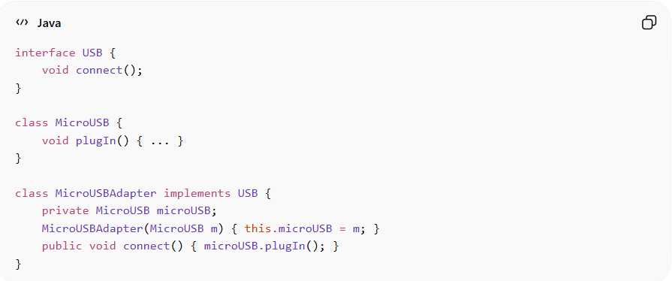
interface USB {
void connect();
}

class MicroUSB {
void plugIn() { ... }
}

class MicroUSBAdapter implements USB {
private MicroUSB microUSB;
MicroUSBAdapter(MicroUSB m) { this.microUSB = m; }
public void connect() { microUSB.plugIn(); }
}
Advantages:
• Enables reuse of existing code
• Makes classes work together without modification
• Reduces client complexity
Disadvantages:
• Adds extra layers → slight overhead
• Can increase system complexity if overused

2️⃣ Composite Pattern
# Source: AI Source: Provided by: [Data Path: Persons Table -> ID Column: 1, Name_En Column: Motasem Essam] -> From: [ChatGPT] on [1/23/2026]
Treats individual objects and compositions of objects uniformly.
Example:
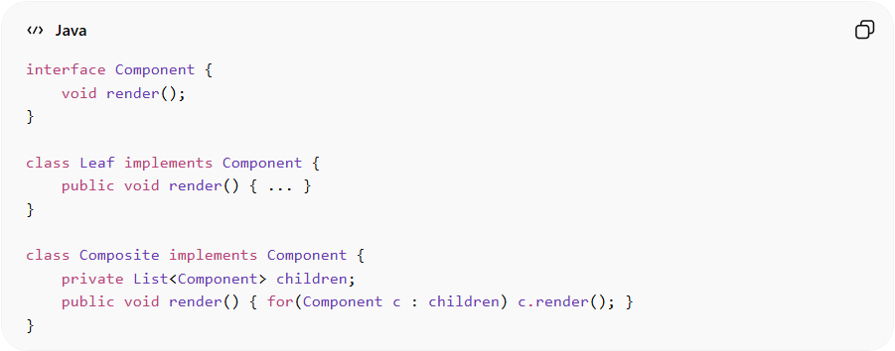
interface Component {
void render();
}

class Leaf implements Component {
public void render() { ... }
}

class Composite implements Component {
private List<Component> children;
public void render() { for(Component c : children) c.render(); }
}
Advantages:
• Simplifies tree structures (e.g., GUI components, file systems)
• Client code treats single objects and composites uniformly
Disadvantages:
• Can make design more general than necessary
• Harder to restrict types of components in a tree

3️⃣ Decorator Pattern
# Source: AI Source: Provided by: [Data Path: Persons Table -> ID Column: 1, Name_En Column: Motasem Essam] -> From: [ChatGPT] on [1/23/2026]
Adds responsibilities to objects dynamically without modifying original classes.
Example:
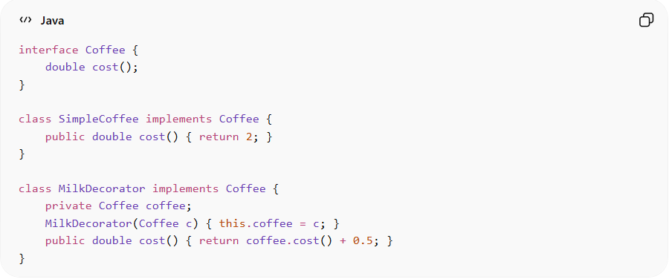
interface Coffee {
double cost();
}

class SimpleCoffee implements Coffee {
public double cost() { return 2; }
}

class MilkDecorator implements Coffee {
private Coffee coffee;
MilkDecorator(Coffee c) { this.coffee = c; }
public double cost() { return coffee.cost() + 0.5; }
}
Advantages:
• Adds functionality at runtime
• Avoids subclass explosion
• Promotes flexibility
Disadvantages:
• Can create many small classes
• Can make code harder to understand

4️⃣ Facade Pattern
# Source: AI Source: Provided by: [Data Path: Persons Table -> ID Column: 1, Name_En Column: Motasem Essam] -> From: [ChatGPT] on [1/23/2026]
Provides a simplified interface to a complex subsystem.
Example:
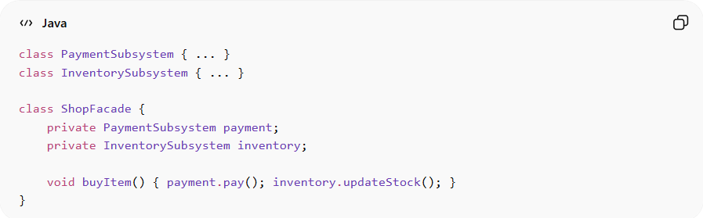
class PaymentSubsystem { ... }
class InventorySubsystem { ... }

class ShopFacade {
private PaymentSubsystem payment;
private InventorySubsystem inventory;

void buyItem() { payment.pay(); inventory.updateStock(); }
}
Advantages:
• Simplifies complex subsystems
• Reduces coupling between clients and subsystem
• Makes system easier to use
Disadvantages:
• Can become a god object if overused
• May hide too much detail, limiting flexibility

5️⃣ Proxy Pattern
# Source: AI Source: Provided by: [Data Path: Persons Table -> ID Column: 1, Name_En Column: Motasem Essam] -> From: [ChatGPT] on [1/23/2026]
Provides a surrogate or placeholder for another object to control access.
Example:
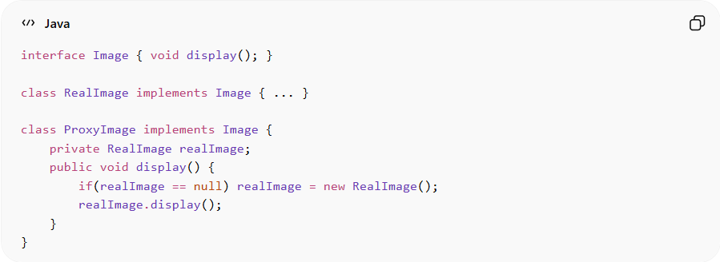
interface Image { void display(); }

class RealImage implements Image { ... }

class ProxyImage implements Image {
private RealImage realImage;
public void display() {
if(realImage == null) realImage = new RealImage();
realImage.display();
}
}
Advantages:
• Controls access to objects
• Adds lazy initialization or security
• Can reduce memory or resource usage
Disadvantages:
• Extra level of indirection
• Adds complexity to the system

6️⃣ Bridge Pattern
# Source: AI Source: Provided by: [Data Path: Persons Table -> ID Column: 1, Name_En Column: Motasem Essam] -> From: [ChatGPT] on [1/23/2026]
Separates abstraction from implementation, allowing them to vary independently.
Example:
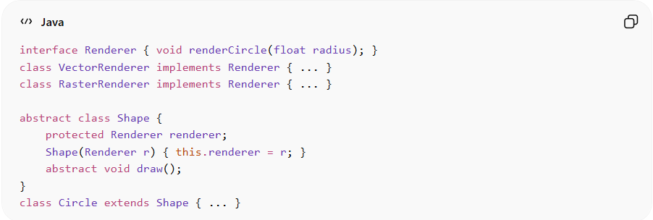
interface Renderer { void renderCircle(float radius); }
class VectorRenderer implements Renderer { ... }
class RasterRenderer implements Renderer { ... }

abstract class Shape {
protected Renderer renderer;
Shape(Renderer r) { this.renderer = r; }
abstract void draw();
}
class Circle extends Shape { ... }
Advantages:
• Decouples abstraction and implementation
• Increases flexibility and scalability
• Supports independent extension
Disadvantages:
• More complicated design
• Increases number of classes

7️⃣ Flyweight Pattern
# Source: AI Source: Provided by: [Data Path: Persons Table -> ID Column: 1, Name_En Column: Motasem Essam] -> From: [ChatGPT] on [1/23/2026]
Reduces memory usage by sharing common state among multiple objects.
Example:
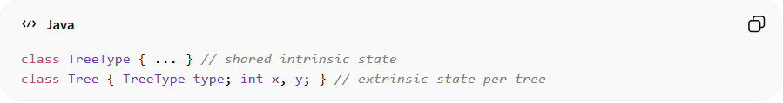
class TreeType { ... } // shared intrinsic state
class Tree { TreeType type; int x, y; } // extrinsic state per tree
Advantages:
• Saves memory for large numbers of objects
• Supports efficient object sharing
Disadvantages:
• Can make code harder to understand
• Extra management needed for intrinsic/extrinsic state

⚡ When to Apply Structural Patterns
# Source: AI Source: Provided by: [Data Path: Persons Table -> ID Column: 1, Name_En Column: Motasem Essam] -> From: [ChatGPT] on [1/23/2026]
• System has complex relationships between objects or classes
• You want to simplify or standardize interactions
• Need to reuse, extend, or combine components flexibly
• Common in UI frameworks, graphics systems, and large enterprise apps

